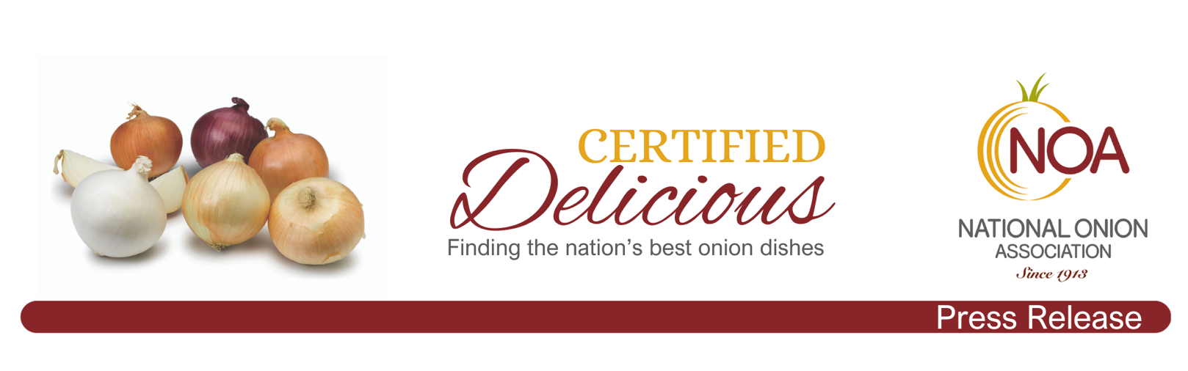
Nov. 4, 2023

Contact:
Greg Yielding
National Onion Association
(970) 381-8172
gyielding@onions-usa.org
Glendale restaurant’s onion soup is “Certified Delicious”

The National Onion Association (NOA) has awarded its first “Certified Delicious” award to Bull & Bush Brewery in Glendale, Colo., for its menu item, Nana’s French Onion Soup.

With this designation, the NOA has sent the restaurant’s owners a framed copy of their award, and it has designated the restaurant’s French Onion Soup as “Certified Delicious” on the National Onion Association website, onions-usa.org/news/certified-delicious.

“Today’s restaurants have many choices when it comes to their menu items and how they prepare those menu items. They can buy frozen, canned or freeze-dried. But when they choose to use fresh ingredients and take the time to make a delicious dish such as French Onion Soup, they have made the conscious decision to value and serve quality,” said Greg Yielding, executive vice president and chief executive of the NOA. “This is an effort that not every restaurant commits to, and the NOA wants to recognize that commitment with its ‘Certified Delicious’ award.”

At Bull & Bush, Nana’s French Onion Soup is a sublime treat for the tastebuds. It is packed with caramelized onions in a decadent beef jus, served with traditional Gruyere cheese melted atop country bread, and topped with friend onion strings.

The NOA’s culinary team is composed of onion growers throughout the country who look for onion dishes in which chefs take the time and care to prepare them in not only the traditional ways but with some unique creativity. Originally considered a peasant’s meal, French Onion Soup was introduced in the 18th Century to the royal court at Versailles at the insistence of the nobility. The soup was introduced in the United States 1861. Today, it is a fan favorite.

The National Onion Association was established in 1913. We represent onion growers throughout the country who take great pride in delivering safe, fresh, and delicious onions to restaurants and supermarkets. We know onions, and we applaud the chefs who go the extra mile to make the most out of their onion dishes.

###

